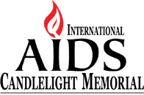 | 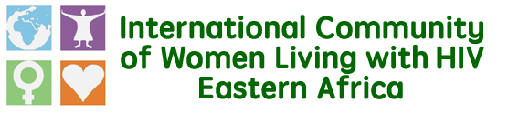

Fast track the AIDS Trust Fund, review SRHR guidelines for us to ‘End HIV together’
Today May 17, 2017, The International Community of Women Living with HIV Eastern Africa joins women living with HIV and their communities in commemorating the International Candlelight Memorial. This day gives us the opportunity to come together to remember and honour the women and girls that have been lost to the epidemic, to remember and celebrate those women who selflessly contributed to the successes that we celebrate today in the fight against the epidemic.
While we remember such women, we must not forget that there is still work to do in ensuring that women and girls living with HIV in their diversities are treated with dignity and that they continue to enjoy their rights since they continue to report violations such as those against their SRHR rights.
As we commemorate the Candlelight Memorial 2017 under theme of ‘Ending AIDS together’, ICWEA is calling on the governments of Kenya, Burundi, Uganda, Rwanda and Tanzania to particularly look into the following issues if we must End HIV together:
AIDS Trust Fund: Reduction of donor support and financing for HIV in the region calls for more efforts in raising domestic funding to respond to the epidemic. We are encouraged by the fact that most governments in the region are seeking to set up AIDS Trust Funds to bridge the funding gap. We particularly congratulate Tanzania that recently innaugurated their AIDS Trust fund while encouraging the rest to fast track the establishment of AIDs Trust Funds as a means to finance the HIV response in the region.
While we support the idea of the Trust funds, we ask that deliberate efforts be made by each of the governments to develop a robust financial management and tracking system for managing the funds. This is essential in generating confidence in the ATF among nongovernmental stakeholders and could lead to investments from diverse sources. We further ask our governments to take into account the voices and concerns of the beneficiaries especially women living with HIV in their diversities while developing the guidelines for the funds.
WHO SRHR Guidelines for women and girls living with HIV: Women and girls living with HIV in the region continue to face SRHR violations. This constrains them from accessing HIV and sexual and reproductive health interventions. We however, want to take the occasion to celebrate the recently released new SRHR guidelines by the WHO intended to address SRHR needs of Women and Girls living with HIV. While we celebrate the new guidelines, we ask the governments in the region to review their SRHR guidelines in line with those released by WHO which give guidance on areas such as psychosocial support, ageing and healthy sexuality, economic empowerment and resource access (including food security), integration of SRHR and HIV services, empowerment and self-efficacy around safer sex and reproductive decision-making, facilitating safe disclosure for women living with HIV who fear or experience violence, modes of delivery for best maternal and perinatal outcomes (specifically caesarean section), and safe medical and surgical abortion.
PrEP Guidelines: We as a community are excited by the fact that PrEP is slated to be included in the PEPFAR-supported DREAMS initiative focused on young women and adolescent girls. This is a good step towards having more prevention options for women and girls living with HIV who are in discordant relationships. There is however need to ensure that PrEP introduction in no way diminishes the focus on access to quality ART programs for people living with HIV and that policies or guidance documents are made available to guide implementation.

